Minutes of the Parish Council Meeting held on Wednesday 10th September 2025

25.09.10.01
Present: Cllrs. R. Barnes (Chair), Pallett (Vice-Chairman), P. Barnes, Slater and Spillett, SCC Bobbie Bennett, WSC Cllr. Pugh
and the Clerk , Anne Lines. There was one member of the public.

- Welcome - the Chair welcomed everyone to the meeting. He advised that that the meeting would be recorded privately by Cllr P Barnes and the Clerk, Anne Lines.

- APOLOGIES for ABSENCE – Cllr Ball sent apologies.
  - Declarations of interest - NONE
  - Declaration of Interest Dispensations - NONE

- Minutes - the minutes of the Extraordinary Council Meeting on September 2nd 2025 were APPROVED as a true and accurate record.

Public Forum - A resident of the parish spoke about the recent incident involving the alleged killing of sheep by uncontrolled dogs. She highlighted what she described as an apparently indifferent attitude by the dogs owner, agreed with the general feeling that the police response had been insufficient , and that it was wrong to adopt the sheep versus child comparison. Also that the breed of dog was irrelevant., any dog could attack sheep or wildlife. Some things needed to change such as police responses, and possibly legislation too.

5. County, District and Parish Councillors’ Reports
- Cllr. Bobbie Bennett ( Suffolk County Council) spoke about responsible dog ownership. She has raised the incident in Stansfield with the officer from the Community Safety Partnership for the whole of West Suffolk. The officer will use the incident as a case study in a partnership meeting on which sit senior Police Officers, County and District Councils and Health representatives. A protocol for flagging up the Community view of the seriousness and urgency of threats, such as this, is being drafted by Stansfield Parish Councillors and Cllr Bennett said she would support and push the initiative forward.
- Cllr Bennett said the business case for a single Suffolk Unitary Council has been launched, details of which can be found by following the link : One Suffolk Business Case This has been compiled with information and communication with parish and town councils, partners in business, the police and the NHS. The key messages taken from this information are i) the frustration in not being able to contact a named person ii) reassurance that the councillors will still work locally and iii) some parish councils want the option to take on more responsibility whilst others do not want this. The document is long, but Cllr Bennett recommended looking at the parts of the document involving parish councils and locality, as this is key to what people said about strengthening the role of parish and town councils and improving communication.
- The District and Borough Councils will release their business plan next week which will be for three unitary authorities County, District and Borough. In working together, there have been differences but ultimately the plan will go to the Minister and the Treasury. For a decision

Cllr. Sarah Pugh (West Suffolk District Council) spoke, her report can be found on the website click link Parish-Council-Report-Stansfield-10-09-26.pdf She added that Chris Walbrick, Locality Fund Officer , from West Suffolk District Council is keen to introduce himself at the meeting scheduled for 7th January 2026.
Parish Councillors – Speeding was discussed. Cllr Bobbie Bennett said there was still no data from previous Automatic Number Plate Recognition (ANPR) but she will forward the data as soon as she receives it. ANPR sharing has been discussed with other parishes but sharing information is difficult due to data protection. Flashing Signs are an option which record the number of cars and their speeds. Data needs to be collected if a 20mph speed limit is to be applied for.

6. Planning and Development DISCUSSED Planning application DC/25/1162/LB. AGREED unanimously to add no comment from the councillors, allow the planning officers at the District Council to make the decision.

7. Community Matters
- Good Neighbours report that they have provided nearly 100 jobs to residents over the last 2 years. It was felt this is very positive and raised the profile of Stansfield as a caring community.
- Speeding. It was proposed by the annual Parish Meeting that the speed limit in the village should be reduced to 20mph. This entails a number of data collection exercises from speeding vehicles including that not yet provided by Suffolk County Council. The cost of implementing the new limit would fall on the parish.
- The Old Chapel Churchyard. The Autumn graveyard clearance has been completed.
- Report on the Fun Day 20th July 2025 The day was discussed and it was generally felt, a very successful event despite the weather not being favourable. It was unanimously voted to repeat again next year with the main objective to keep it a low cost/low key event. The clerk will look at local school term times and tentatively book the Village Hall for the first Saturday of the summer holidays.
- Assets of Community Value. This is an ongoing project and Cllr P Barnes needs to discuss with Jon Eaton at WSC the list of submissions

25.09.10.02

- DISCUSSED Rest Centre Training/Emergency Plan Update. Rest Centre management training is available and volunteers are being sought. Councillors were encouraged to peruse and check the current Emergency Plan and suggest changes, where required.

- APPROVED annual grant payment of £768.00 to the Village Hall. The Village Website is proposed to be amalgamated with Stansfield Parish Council website. The clerk would post information on the website on a page allocated to Village Organisations.
- DISCUSSED and ADOPTED The Community Engagement Policy
i) DISCUSSED the arrangement for publishing Parish Council Affairs. It was recorded that some items have been omitted from the Parish Pump on more than one occasion. The idea of the PC producing their own newsletter for distribution to Stansfield residents was discussed.
i) Following the clerk’s resignation, a vacancy for the post will be posted with SALC, on the website and also on the village notice board. The formation of an interview panel was discussed , along with publicising the vacancy through a employment agency.

8. Clerk’s Report
Points from the Clerk’s report were reviewed and the following resolved :
- The bank account with Barclays Bank has been closed and the balance transferred to Unity Bank to be placed in savings.
- The post box on Plough Hill has been removed and replaced despite several attempts by the clerk requesting the said post box to be moved to a new position and not be replaced with a new one.
Points still ongoing are :
- Speeding issues, Stansfield PC has invited MP Nick Timothy to a meeting on 30th September 2025 at the Village Hall and it is hoped that speeding through the village will be one of the topics.
- Signatories for Unity Bank are to be changed from R Barnes and P Barnes to: R Barnes, Corlett, Pallet and Slater.
- The sign post at Denston has still not been repaired, clerk to inform Highways,
- The Village sign still needs to be repaired.
- REVIEWED and partially RESOLVED - action points from previous meetings not itemised elsewhere in the minutes, see Clerk’s report..
- Standing Orders. Clerk to post most recent version on website.
- DISCUSSED Financial Regulations. These are not due for renewal until May 2026.
- REVIEWED and APPROVED the Internal Audit with recommendations made.

9. RFO Report
a) RECEIVED and APPROVED/NOTED – the following list of payments, the Bank Reconciliation and a Statement of Accounts
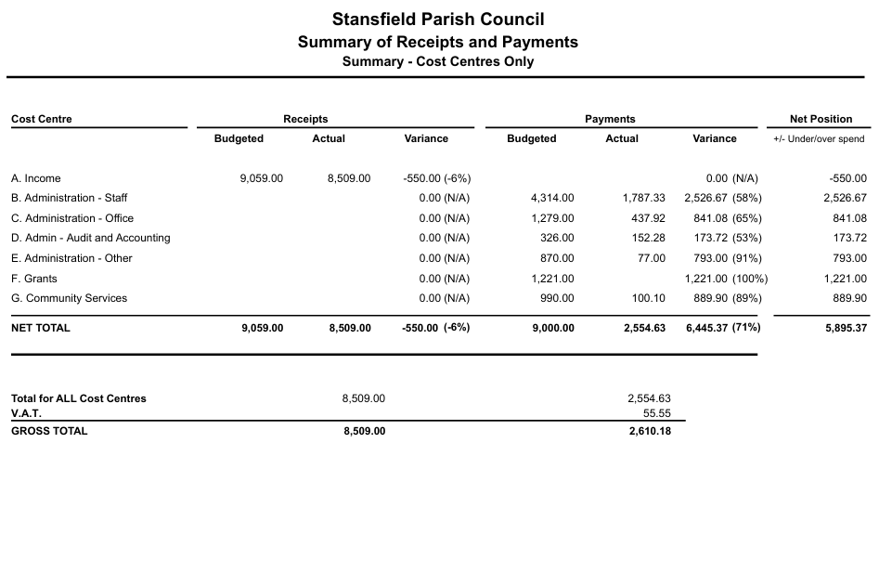

b) No Virements across Cost Codes required.
c) Assets belonging to the Parish Council DISCUSSED and AGREED despite some of their ‘life’ outside the original date provided, no further action required at this time.
d) Banking Arrangements DISCUSSED, see Clerk’s report.
e) A working party to review the budget and precept for 2026/27 APPROVED to be led by Cllrs R Barnes, Ball and Corlett.

10. Agenda items for future meetings –
Action points.
2026 Budget and Precept A working party, led by Cllr R. Barnes, with Cllrs, Corlett and Ball, to consider and present a 2026 Budget (with the appropriate precept to underpin that budget) to the January 2026 meeting.
11. REVIEWED and APPROVED that future meetings will be held in the Village Hall:
September 30th, 2025 at 7pm. A special meeting to which SPC have invited MP Nick Timothy regarding the recent concerning loose dogs and sheep.
January 7th, 2026 at 7pm

March 11th, 2026 at 7pm
May 13th, 2026 at 7pm APCM
May 19th, 2026 at 7pm APM
September 9th, 2026 ay 7pm.

The Chair closed the meeting at 9.18pm

